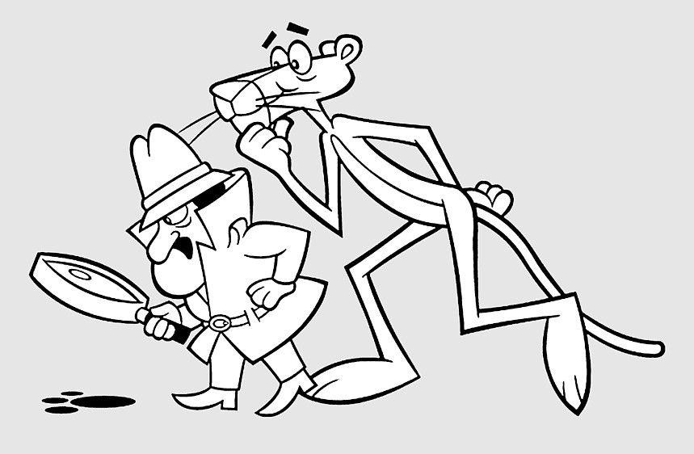
STARLINERS
The 2026 Hinsdale Starliners are under the direction of
Angela Franz and Lori Harris. Consisting of members in
4th through 7th grades, we aim to teach technique and having fun while performing.
Using a mashup of Pink Panther and James Bond, we are bringing a jazz-fueled performance to the floor for your
entertainment. Our detectives will be hard at work to find and catch the sneaky pink thieves.

