**Victor Varsity Winterguard** 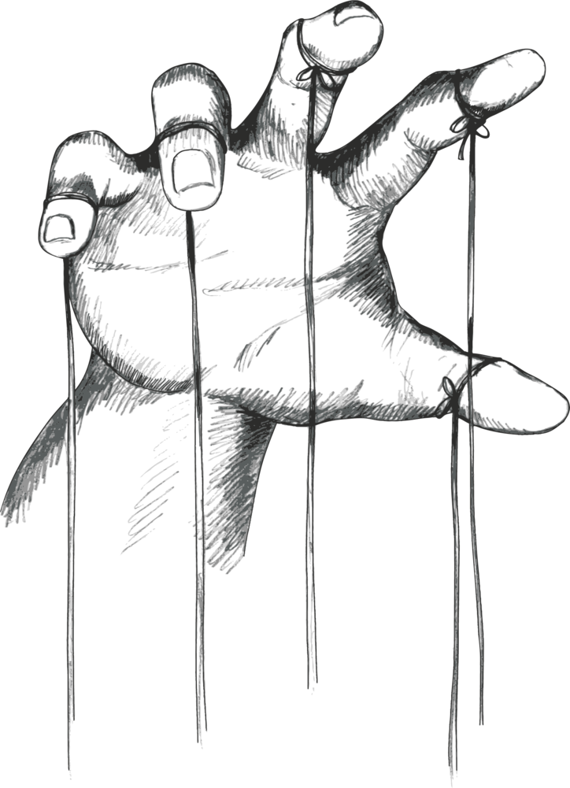

The 2023 Victor Varsity Winterguard is proud to present their show entitled, “Strings.”

The group performs to song selections from Pinnochio, and the Avengers: Age of Ultron.

The group is composed of students ranging from 7th grade to 12th grade. The group is under the direction of Chrissy Eames. Show design is by Michelle Bills and Chrissy Eames. Equipment choreography is by Julia Solan, Lindy Rohr, Rachel Brown, and Chrissy Eames.

The group would like to thank the Victor Band Boosters for their continuous support and love.